The “Ways & Means” Community Foundation
Reading Program Introduction

Date: October 12, 2016 Time: 6:00 p.m.

Location: Detroit Public Library – Redford Branch
21200 Grand River Avenue
Detroit, Michigan 48219

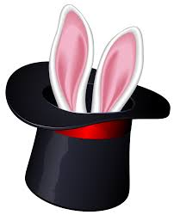

6:00 p.m. Magic Show “The Magic of Reading & Words”
(Performed by Tuskegee Airman - Major Bob Tillman)


6:30 p.m. Reading Program (Reading Eggs) Overview & Instructions

6:45 p.m. Refreshments

7:00 p.m. Computer – Hands on Instructions

For more Information & Registration - Contact Anne Seebaldt @ 248-505-6746

